**Endazhi-Nitaawiging**

**School Board Working Board Session Minutes**



Saturday, February 10, 2024

Time: 9:00 a.m

Working Board Session

In Person at

Endazhi-Nitaawiging Charter School

25065 Highway 1 West

Red Lake, MN 56671

I. Meeting Call to Order

Time: 9:25 a.m

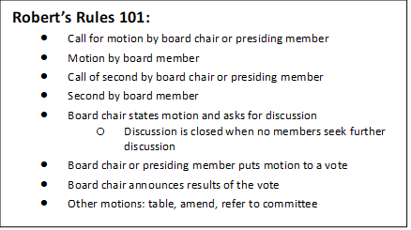II. Roll Call

|  |  |
| --- | --- |
| X | LaGou, Jeffrey –Arrived at 9:38 a.m |
| X | Long, Naomi |
| X | Johnson, Rochelle |
| EX | Nguyen, Hieu |
| X | White, Elizabeth |

III. Prayer & Song

IV. Mission & Vision

*Mission:*  The mission is to prepare each student for college with an enhanced knowledge of the Ojibwe language, culture, leadership, and environmental stewardship.

*Vision:* At Endazhi-Nitaawiging, the vision is to create confident leaders grounded in their true inherent identities and to ensure that they are academically, socially, and spiritually prepared to positively change the community and world.

V. Agenda Approval

A. A motion to approve the agenda for the working board session of

February 10, 2024 as presented.

Motion by White, Second by Long, Action: Motion passed, 4-0.

|  |  |  |  |  |  |  |  |  |  |
| --- | --- | --- | --- | --- | --- | --- | --- | --- | --- |
| X | LaGou | X | Long | X | Johnson | EX | Nguyen | X | White |

X. Open discussion

Board Chair Johnson proposed a flexible learning year with a sample of a Academic school year calendar for 2024-2025 (Pine Point School District #25).

The flexible learning year consists of 45/15 break down (45 days in class/ 15-day break).

Board members discussed the pros and cons of a flexible learning year.

Executive Director will consult with Tribal Council and School District #38 in regards to the plan for the proposed flexible learning year. The consultation will be in regards to tribal operations (family childcare options), food service and transportation.

Board member Long introduced a draft plan for the students during the 15-day break period. The plan will be proposed to Tribal Council along with the flexible learning year plan for 2024-2025 as soon as the plan is finalized (April 2024).

Teacher and parent surveys will need to be conducted. Sylvia (HOS) will include a questionnaire on a survey to parents and teachers about a year round school year (flexible learning year).

Board members discussed timelines to include introducing the flexible learning year to teachers, parents/families, School District #38 and Tribal Council.

XI.       Adjournment

1. A motion to adjourn the meeting at 11:02 a.m.

Motion by Long, Second by White, Action: Motion passed, 4-0.

|  |  |  |  |  |  |  |  |  |  |
| --- | --- | --- | --- | --- | --- | --- | --- | --- | --- |
| X | LaGou | X | Long | X | Johnson | EX | Nguyen | X | White |